VIRTUAL MACHINE

Virtual means virtualization which is not physically present. It’s an operating system running inside another operating system which is not present in real world. Operating system on which another is running called “Host” and Operating system running in virtual machine called “Guest”. E.g. my laptop has Windows 10 and Linux is running on VMware application in windows 10. Window 10 is Host OS and Linux is Guest OS.

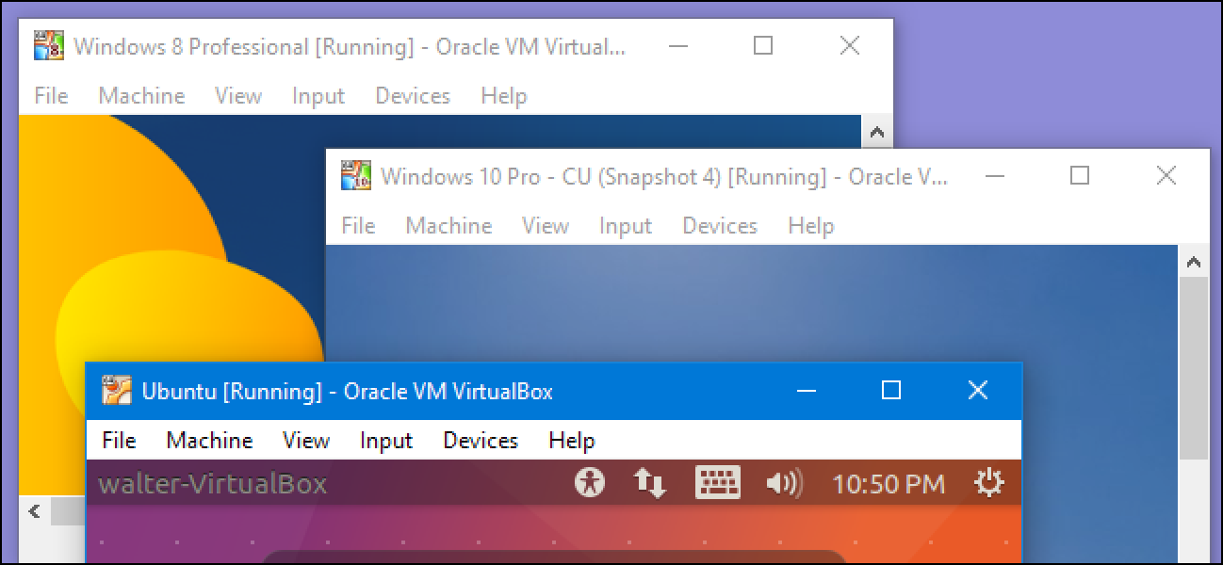

Virtual Machines are computer files that run on a physical computer providing same functionality and service physical computer provides and they run as application on Host. This makes easier to run different types of operating system on single physical computer.

Virtual Machine doesn’t interact with physical computer. They require a software called Hypervisor. Hypervisor is lightweight software which interacts between Guest OS and Physical Hardware. This provides each Virtual Machine the resources that allocated and manage the Virtual Machines. This separates the Operating System and applications from the hardware and then it get divided into individual Virtual Machine. Now, Each Virtual Machine can work independently by sharing the original resources like RAM, Memory, Storage etc.

The desire to run multiple operating systems together is the main reason to switch toward virtual machines which leads to time sharing as multiple tasks are being operated together. Guest OS will use the processor of Host OS which makes the system quite slow. We can also pause our virtual machine and resume afterward and continue working. You can resume from where and on which state you stopped earlier. It will continue from that only. But, If we use different operating system in another way we have to shut down first to work on another and pause/resume facility is their except Virtual Machine.

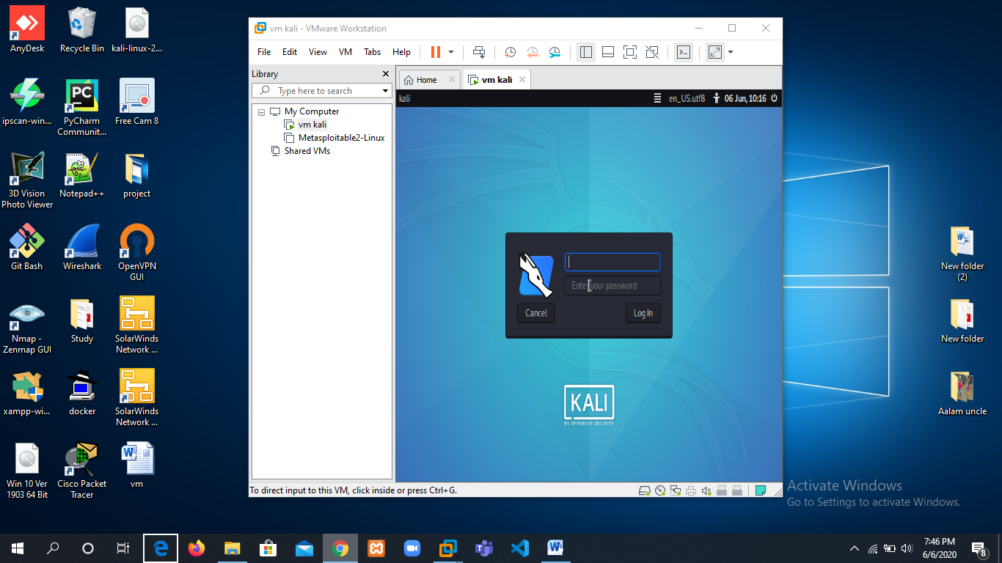

**How Virtual Machine Work**

VM need a host to run on. It can be your laptop, server in a data center or instance on the cloud.

In Virtual Machine when server is powered on and Hypervisor boots. When boots completed, it interacts with all physical resources on the system like CPU, RAM, Storage and NICs. Then the Hypervisor slice these hardware resources into virtual versions which further packaged into Virtual Machine (VM). Then we install Operating System and applications on each VMs. Virtual Machine’s Hypervisor perform Hardware Virtualization as it shares hardware resource from the host.

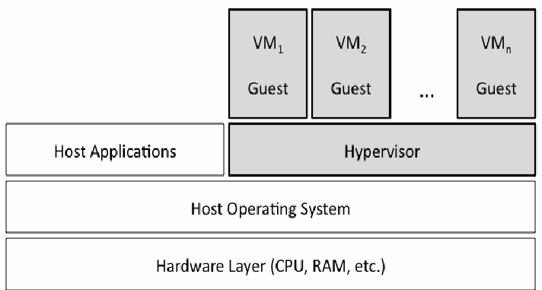

**How to setup VMware**

To setup Virtual Machine, You just need OS ISO File and virtual machine software. In market there are many Virtual machine software present like VMware, Virtual Box, parallel Desktop, etc.

We just have to import and install ISO File of Operating system you want to use. E.g. we have windows 10 installed on Physical operating System and want to use Kali Linux parallelly.

Download ISO File of Kali Linux and VMware on system. Create a virtual machine on VMware and import ISO File and then install and setup. You can use that Kali Linux just like an application on windows 10 and you can create as many virtual machines you want to. Handling virtual machines are very easy.

To establish connection between VMware/Virtual box with Host we have to configure Networking mode. There are different types of Networking modes i.e. NAT, Bridge, Internal, NAT Service and Host-only. This is selected under network settings.

* NAT (Network Address Translation): Separate subnet is assigned to virtual machine. This is the default mode in VMware or virtual machine which allows to access external network from a virtual machine but no outside access to Virtual Machine allowed as they are protected. Here, Guest OS connects to internet through a wireless router and the router is placed between each virtual machine and the host. Virtual machine networking engine is the router here which maps traffic transparently.
* NAT Service: This creates an internal network allows outbound connection. It allows communication between each other inside the network and preventing system outside the network from directly accessing systems inside but allowing outside systems communicate through TCP and UDP via IPV4 and IPV6.
* Bridge: Virtual machine and host will be in same network and can access by all computers in your host network. In bridge networking, Virtual Box uses net-filter driver on host system which filters data from physical network. Virtual machines can talk to each other and with host if connected through Ethernet cable.
* Internal: This is similar to bridge as Virtual Machine can directly communicate with outside world but will be limited to other VM on the same host and physical connection.
* Host-only: In Host-only networking, Virtual box creates a new software interface. This is useful where multiple virtual machines are shipped together and designed to cooperate.

**Why virtualization and why not?**

There are many reasons to use something or not to use. Everything depends on your purpose. If it satisfy your needs you will use that resources and if not satisfy your demand, you will not use.

**Why Virtual Machine to use**

* People use virtual machine for experimental purpose, it provide safer environment. So if something gets wrong only Virtual will be affected, host operating system will remain unaffected. To solve, they just terminate the virtual machine without harming Host operating system.
* If want for shorted period of time. It is easier to setup when you need and terminate when done.
* Dozens of operating systems could be installed.
* Both Host OS and virtual machine OS can work simultaneously, It is useful when you want to use both operating system at the same time.
* Easy to switch between Operating systems.
* When creating OS in Virtual machine, you also create a virtual hard disk so, it won’t affect the Host OS if goes something wrong.

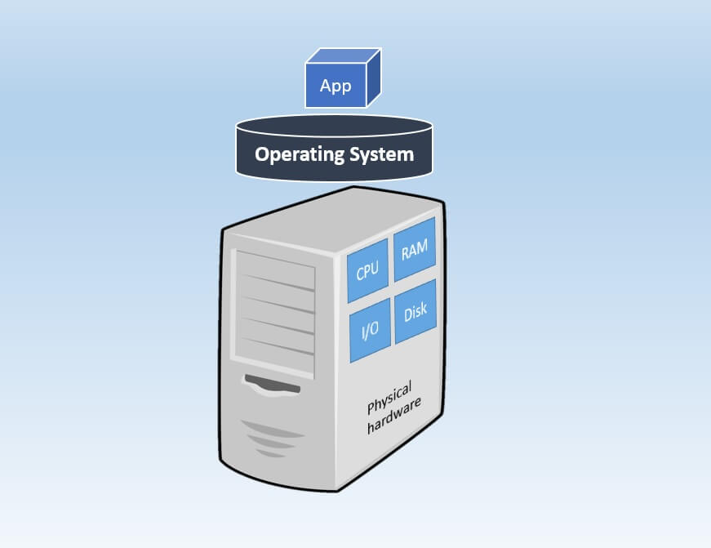

**Why not ?**

* Process is quite slow as OS running on virtual machine access hardware indirectly. They have to go through Host Operating System which makes computer slow. So, We need to have powerful Host can be done by increasing RAM.
* An OS on Virtual machine doesn’t have access to system resources. Both Host OS and VM OS have to share same resources as virtual machine is running inside Host.
* System will be slower when multiple virtual machines will be running on same Host as they multiple Operating Systems sharing the same resources.
* Virtual Machine will not satisfy, if you want to use multiple Operating Systems for heavier games or other heavier program.

To use number of operating systems on a single system we can use duel boot or Virtual Machine. These both can be used to run multiple operating systems on single physical computer. But both have their own specifications. In Duel Boot, You can’t run both operating systems together. You have to shut down one Operating system to use another whereas In VM, Both Operating System could be used parallelly by just minimizing as we do with application.